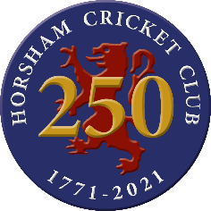
CRICKET CLOTHING BUNDLE FOR 2022
ORDER FORM - BOYS
Player Details
Player’s Name
Parent’ Name
Address
Post Code
Contact Tel Number

If a parent has more than one boy in the Junior Section and wishes to order new kit for both of them then each of their names can be entered into the “Player’s Name” box.

Size Requirements
 | Matrix SS Shirt | Training Top | Training Shorts
Shirt / Training Top Sizes
Junior 9-10 years |  |  | X
Junior 11-12 years |  |  | X
XXS |  |  | X
XS |  |  | X
Small |  |  | X
Medium |  |  | X
Large |  |  | X
XL |  |  | X
XXL |  |  | X
Training Shorts (Waist Measurements)
Junior 9-10 years 58-62 cm | X | X
Junior 11-12 years 62-66 cm | X | X
XXS 64-68 cm | X | X
XS 68-74 cm | X | X
Small 74-82 cm | X | X
Medium 82-90 cm | X | X
Large 90-98 cm | X | X
XL 98-106 cm | X | X
XXL 106-108 cm | X | X

For more information on sizes please look at GN’s Clothing Size Guidelines on the Club’s GN Webshop. If this form is being completed for more than one individual, please remember that each player is only allowed one playing shirt, one training top and one pair of training shorts.
Club caps only come in one size but can be adjusted to fit different head sizes. There is no need to order caps as each clothing bundle will automatically have one included.
Please remember that all Club members must wear the appropriate cricket clothing next season – it is not optional.
The completed order form must be returned to colin.mitcham@btinternet.com as soon as possible.

Parent Name ………………………………………………………………………….
Date ………………………………………………..

